## 

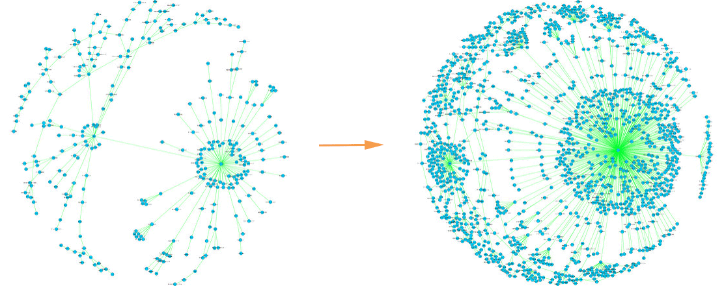

Turning Learn/SEO into a Center of Learning

# 

# 

# Overview

It’s time to take our out-dated, jerry-rigged Learn/SEO section and turn it into the destination for digital marketers looking to up their digital marketing game.

What if we had one Learn Center where a digital marketer could pick and choose the resources they need and want to learn more about from a variety of topics: SEO, Content Marketing, Local SEO, and Social and at a variety of skill levels? Even better: what if that Learn Center then became the topic-specific environment from which they connect to the rest of our offerings?

# 

# Contents

Goals

Audience

Unanswered questions

Early iterations

Inspiration

Background work completed to date

Specifications

Milestones

# The business case for a learn center

In a user research study, 50 out of 50 participants said they found Moz through The Beginner’s Guide to SEO. We’re known for our educational resources and they’re how we got to where we are - growing from Rand’s blog to a powerhouse of SEO and digital marketing education. Historically, those resources have not only attracted customers but also taught them to think of SEO in a Moz-centric way, using Moz tools and verbiage in their daily work.

But we’re losing ground. Ahrefs is showing off their new link metrics, SEMrush is being [lauded for their data](http://www.99signals.com/semrush-vs-moz-best-seo-tool/), and our growth…

To regain our position at the front of the SEO/digital marketing tools charge, we need to overhaul our existing learn resources and build something exceptional that puts a new “generation” of digital marketers in a Moz-centric state of mind. Something that shows them how to be better digital marketers and gets them hooked on using our tools and language as part of their everyday workflows.

**Global Nav 2.0**

This project is not meant to overhaul our navigation, but there are several goals we wanted to achieve with the global navigation project that were just too much to bite off at the time. The learn center is the next step in addressing the following needs:

* Helping people learn about new tools
* Presenting search results in a meaningful way
* Addressing learning for new and beginner users
* Giving users one entry point for learning resources (instead of choosing between blogs, guides, Q&A, etc.
* Providing a centralized resource for learning

# Goals

1. Attract potential customers to our funnel by creating one centralized, kick-ass resource for all of our educational content.
2. Educate the next generation of digital marketers and give current digital marketers the information they need to understand the importance and how-tos of online marketing.
3. Provide one home for our educational content so we can focus on creating and maintaining best-in-class content.

# Audience

Beginner and intermediate digital marketers. The Learn Center will provide resources for the self-directed learner with easy transitions for users who prefer a paid workshop model.

For the record, the difference between our learning resources is as follows:

* Learn section - anytime education for self-learners
* Mozinars - directed learning on a regular schedule
* Moz Services - tailored learning at your pace and on your schedule
* Moz Blog - timely information for intermediate to expert users who want to level up their skills or keep up with changes in the industry.

# Early iterations

## Global Nav Card Sort Project

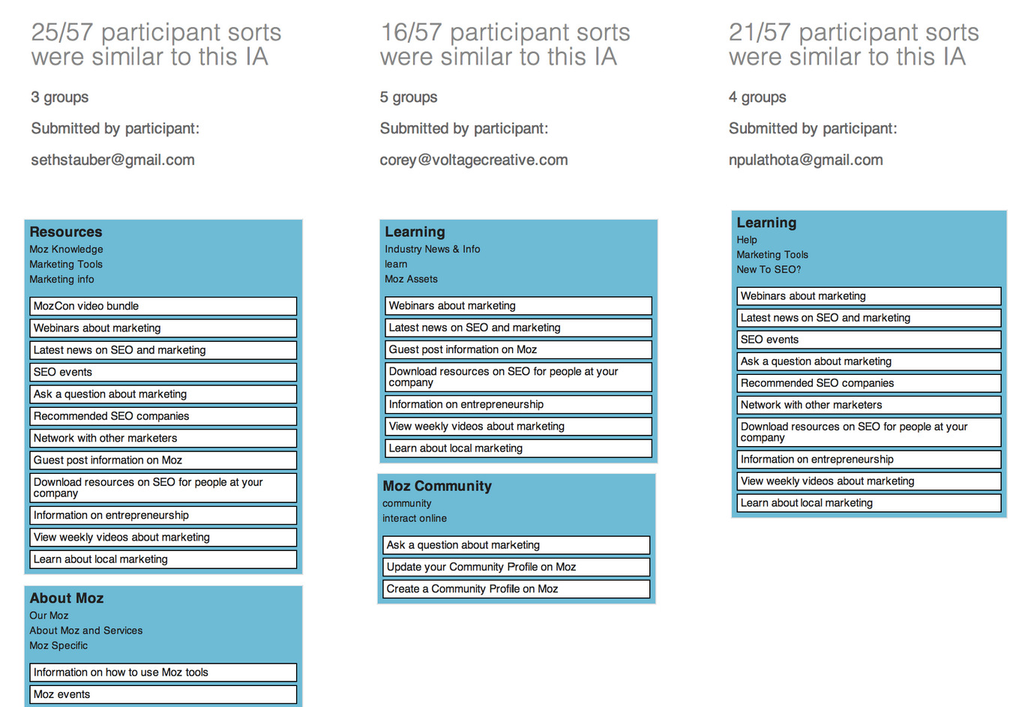

Difference between foundational learning and latest news

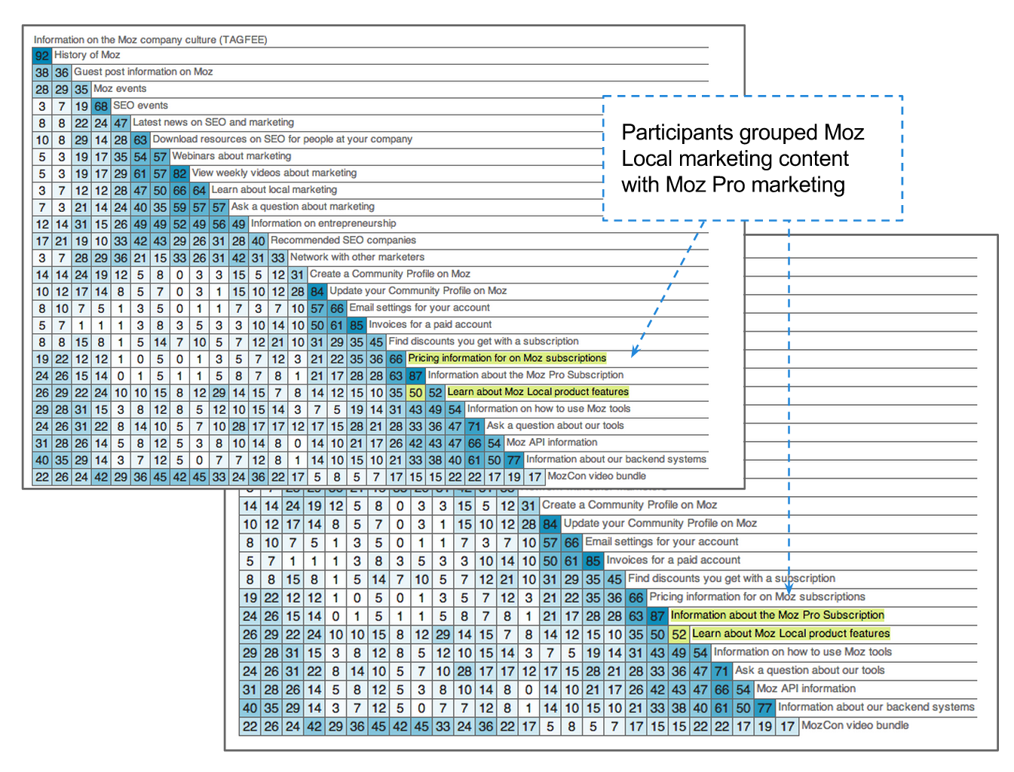

Grouping local learning with other learning

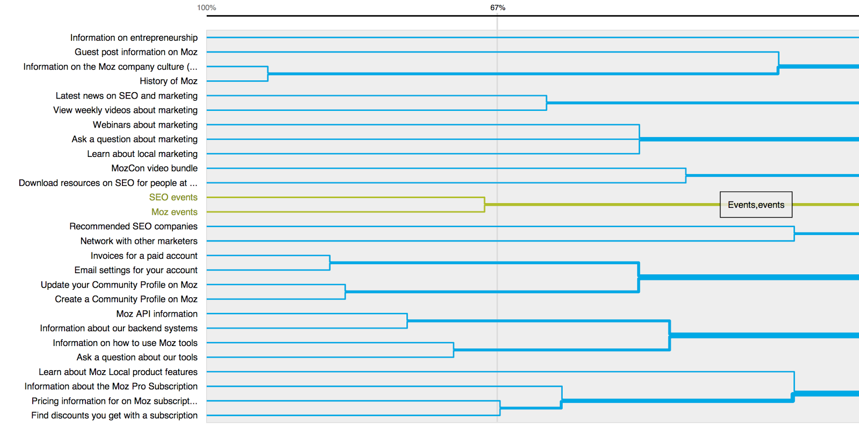

Tools separate from learning - but not from each other

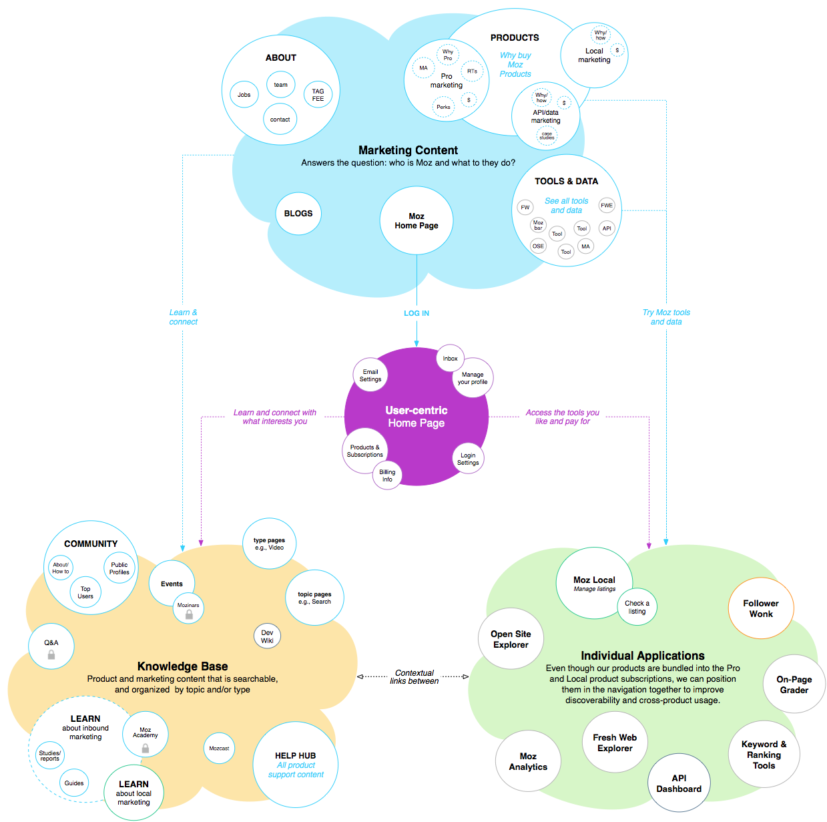

Where learning fits in the conceptual model

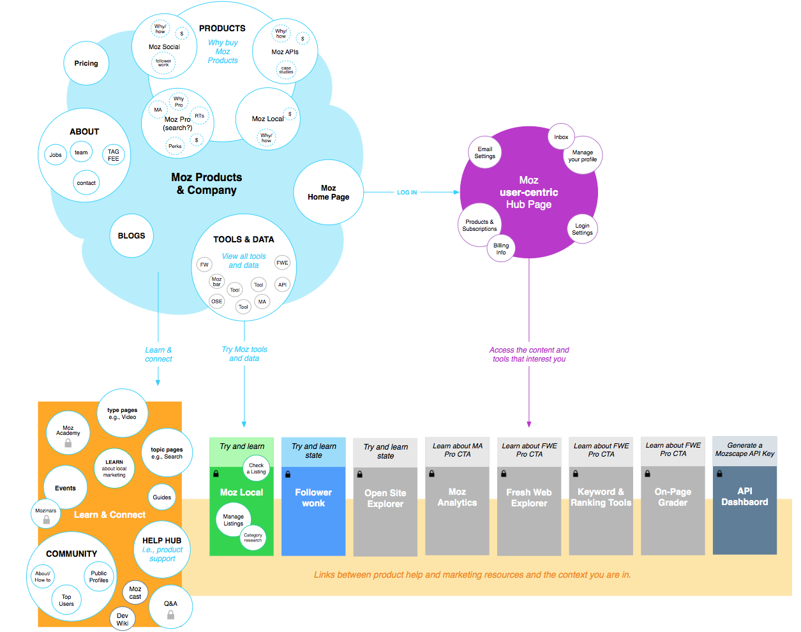

## SEO Best Practices revamp

Courtney worked on [wireframes](https://seomoz.atlassian.net/browse/MKTG-564) for this.

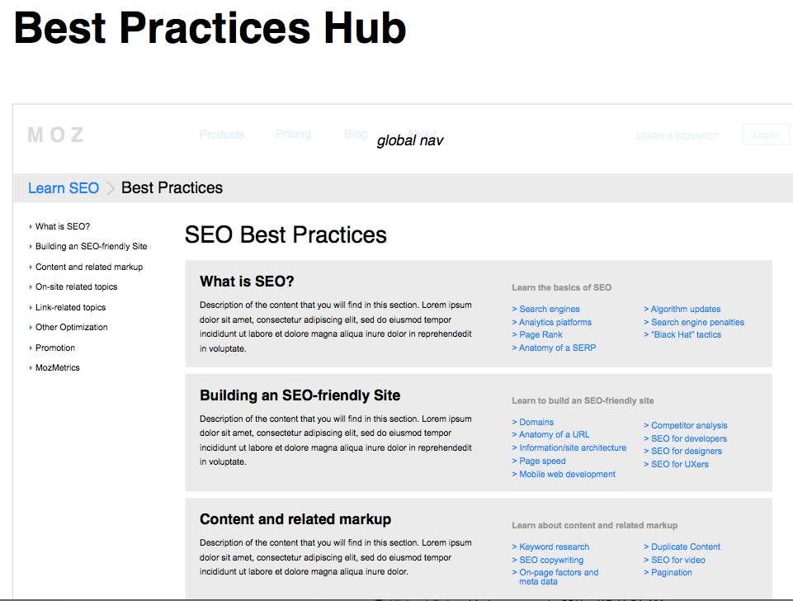

What I like about this is how well it organizes the information into overarching topics and subtopics. What I’d like to see more of is space for visuals because it’s pretty text heavy.

## [How to Learn SEO - Choose Your Own Adventure](https://moz.com/blog/learn-seo-cyoa) blog post

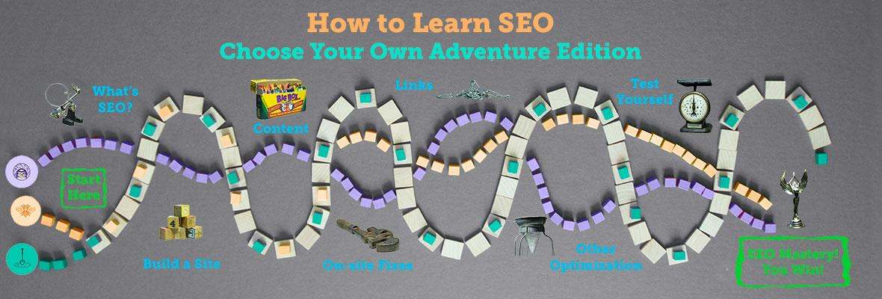

This experience overall is a little messy (I made it myself! And only had access to anchor links for organizing the information), but what I’d like to carry over for this project is the separation of learning tracks based on personas. In this case those were: SEO Newbie, General Marketer, and Advanced SEO.

# Inspiration

[Khan Academy](https://www.khanacademy.org/) comes up over and over for the easy interface and how they display multiple topics so cleanly and it’s simple to drill down.

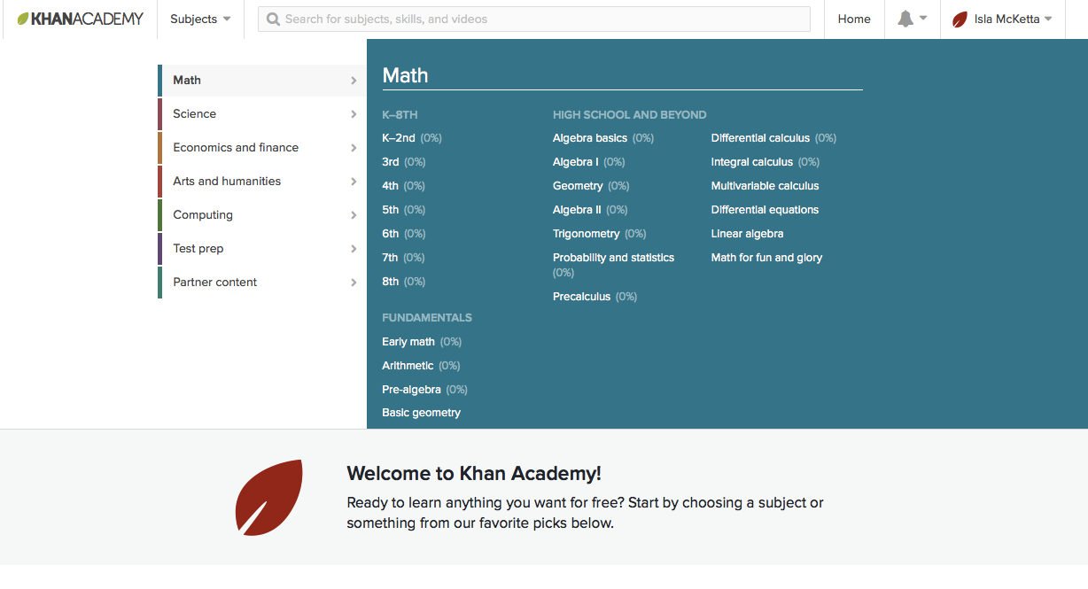

I like the way the [Washington Trails Association](http://www.wta.org/) gathers a lot of different resources in one place without looking (too) cluttered (although they could use a little streamlining).

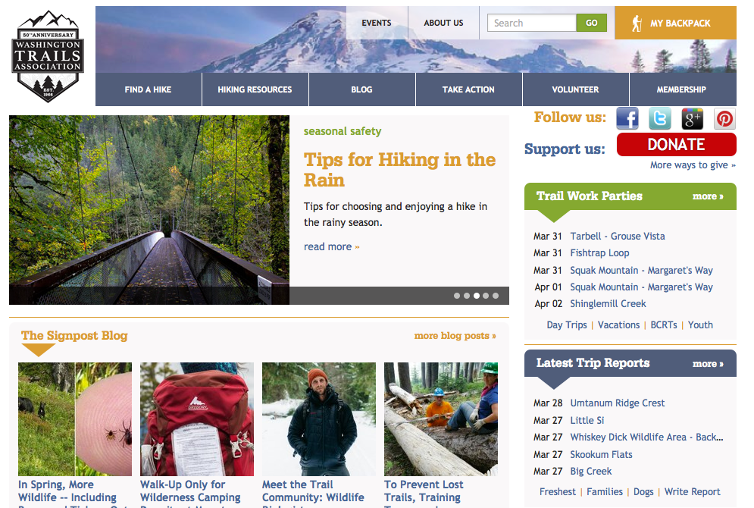

And I love the way the info for [this course at edX](https://www.edx.org/course/conversational-english-skills-tsinghuax-30640014x-1) is all spelled out in one easy glance.

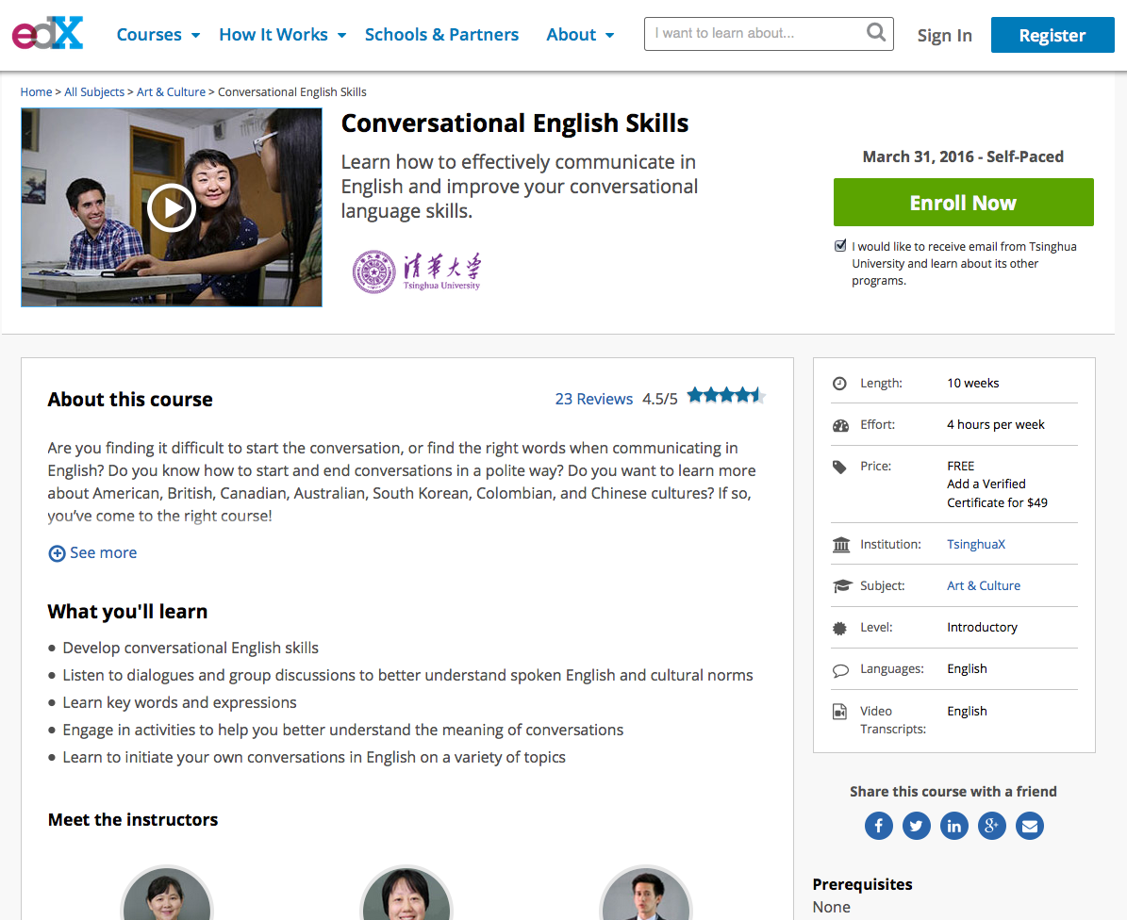

[Adobe](https://helpx.adobe.com/illustrator/tutorials.html) does a good job of helping people know where to start based on skill level.

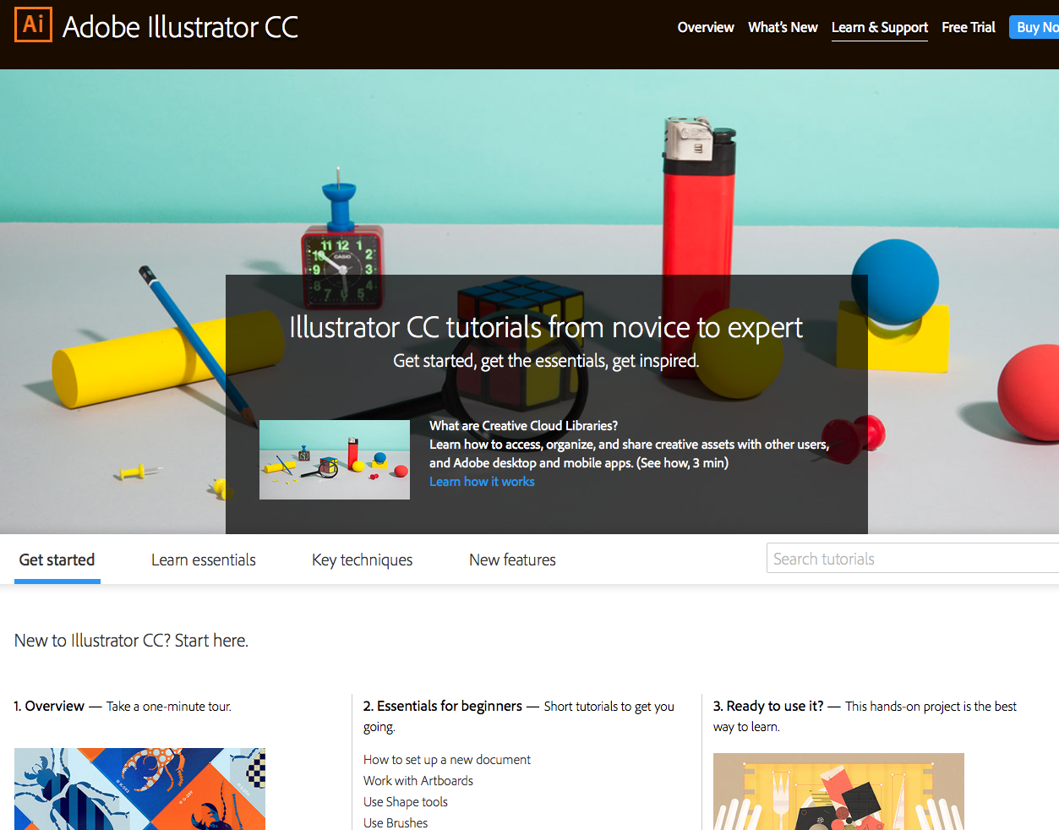

I like A LOT of things about the way [Distilled U](https://www.distilled.net/u/) is organized and their content. They have definitely chosen the courses model with links to resources at the end of each course. Their courses are (mostly?) paid. I do not want to rip off what they are doing, but I definitely want to learn from it.

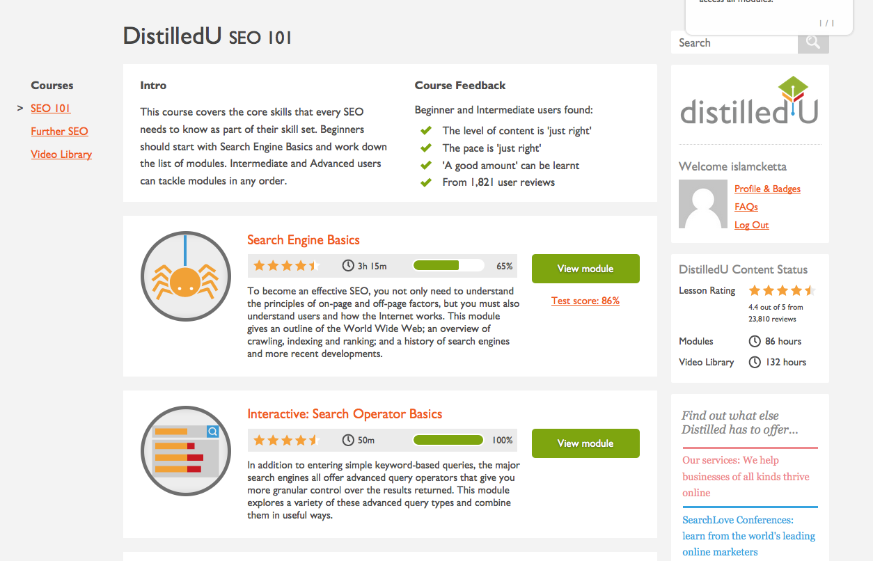

Regardless of whether we do full-on courses, I really like the interactive exercises on Distilled U - they’re a good chance to practice.

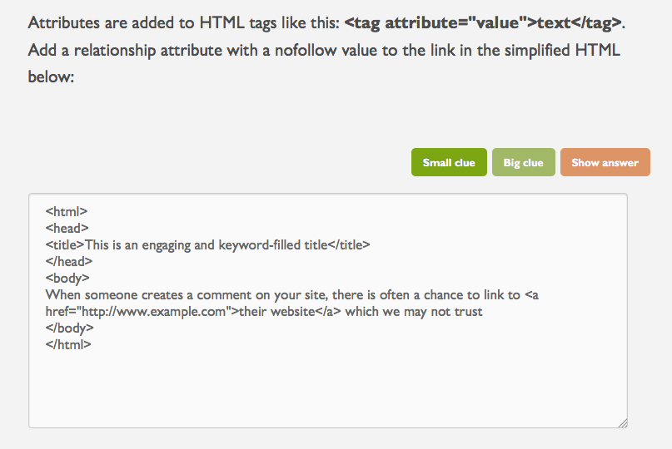

[A more in-depth look at other learning centers lives here.](https://docs.google.com/spreadsheets/d/10VHDpMBCS2Ha7rF21vwSYLCW-dtfgIScY06HwENt3uM/edit#gid=0)

# Background work completed to date

* In late 2014, Trevor gathered together some [research on the competition](https://docs.google.com/presentation/d/1r6TrZhgZrkQGwWATgnL5TMSPeDY-7XRmtyPvWRIPX7U/edit#slide=id.g534612368_012) including key takeaways.
* Also in 2014, Trevor created an [outline of our existing Learn resources](https://docs.google.com/document/d/1umLnrkQ8MuF9u23kq7s29HkVEBkxJPJdvfGo5hrE6rQ/edit).
* [Audit (and partial update) of SEO Best Practices content](https://docs.google.com/spreadsheets/d/1laOtzU81yR_oLJ9MsPJoOiduwLXEXMbMa-_0JcvRWkg/edit#gid=0).

# But what does it look like?

There is so much beauty to be revealed [here](https://docs.google.com/presentation/d/1yjCTBqqaT-Dfy5_o7BWee8_JPrjyfJbVyUBsDtWI8fg/edit#slide=id.g14e17e8317_0_0).

Remember:

* This is education about the industry not the products, but it needs to tie to the products at the end as a resource or in context without being salesy.
* The Learn Centers are the foundations of knowledge and should change only periodically. There should be a way to connect to the topic-specific newsletter (Moz Top 10, Local Top 7) for the latest news.
* Connect to Q&A to ask in-depth/current questions.